IMovies – Functional Specification Document

1. Introduction
- Project title: IMovies – Movie Ticket Booking Platform (MERN stack)
- Team members: SWUID2026403326

2. Project Overview
Purpose. IMovies lets customers find a movie, pick exact seats for a show and pay online, while admins run the catalogue, theatres, show schedule and bookings from a separate panel.
Customer features
- Register, log in, edit profile and change password
- Browse, search and filter movies by genre, language, now showing / coming soon, with sorting
- Movie page with cast, rating, reviews and showtimes by city and date
- Interactive seat map (max 10 seats, live availability) with a 10-minute seat hold and countdown
- Simulated payment by card, UPI, net banking or wallet
- E-ticket with booking ID, printable; booking history; cancellation up to 2 hours before the show with simulated refund
- Star ratings and reviews; favourites and watchlist (email when a watchlisted movie gets a show)
Admin features (at /admin/login)
- Dashboard: revenue, tickets sold, top movies, last 7 days
- Manage movies, theatres and screens (custom seat layouts)
- Schedule shows with per-seat-type pricing and overlap protection
- View and cancel all bookings; activate, deactivate or delete users

3. Architecture
Frontend (React 19 + Vite). A single-page app in plain JavaScript/JSX using React Router v6. App.jsx defines the routes; RequireAuth guards customer pages (role="user") and the admin area (role="admin"). Login state lives in AuthContext, API calls go through api.js, and shared UI sits in components/ (Navbar, Footer, MovieCard, Poster, ui.jsx). The Vite dev server proxies /api to port 5000, so the browser sees one origin and the login cookie works without CORS setup.
Backend (Node.js + Express 4). server.js configures the app (helmet, CORS, JSON parser, cookie-parser, morgan, rate limiting on login/register) and mounts eight route groups under /api: auth, admin, movies, theatres, shows, bookings, reviews and favourites. Controllers hold the logic; middleware handles authentication, role checks, ObjectId validation and centralised errors. utils/ holds seat logic, token generation, the simulated payment gateway, email sending and the seed script.
Database (MongoDB with Mongoose 8). Eight collections:
Collection | Key fields | Relations
User | name, email (unique), hashed password, phone, isActive | –
Admin | name, email (unique), hashed password | –
Movie | title, description, genre[], language, duration, certificate (U/UA/A/S), cast[], releaseDate, poster, trailerUrl, averageRating, ratingCount, isActive | status (upcoming / now showing) is derived from releaseDate
Theatre | name, city, address, screens[] (name + row layout: row, seats, type Regular/Premium/Recliner), isActive | embeds screens
Show | screenId, screenName, startTime, endTime, prices per seat type, bookedSeats[], isActive | movie, theatre
Booking | bookingCode, seats[] (seatId, type, price), totalAmount, status (pending/confirmed/cancelled/expired), expiresAt, payment (method, status, transactionId, paidAt) | user, show, movie, theatre
Review | rating 1–5, comment (max 1000 chars); one per user per movie | user, movie
Favourite | type (favourite / watchlist); unique per user, movie and type | user, movie

4. Setup Instructions
Prerequisites
- Node.js 18 or newer (check with node -v)
- MongoDB: either MongoDB Community Server installed locally, or a free MongoDB Atlas cluster whose connection string goes in MONGO_URI
Installation
- Extract the project and open two terminals, one in server/ and one in client/.
- In server/, run npm install.
- Open server/.env and set the variables below (change JWT_SECRET to a long random string).
- Run npm run seed to create the admin account, sample movies, a theatre and shows (it only seeds an empty database).
- In client/, run npm install.
Variable (server/.env) | Purpose
PORT | API port (default 5000)
NODE_ENV | development or production (production makes cookies secure; sameSite=none)
MONGO_URI | MongoDB connection string
JWT_SECRET | Secret used to sign tokens
JWT_EXPIRES_IN | Token lifetime (default 7d)
CLIENT_URL | Allowed CORS origin (default http://localhost:5173)
SEAT_HOLD_MINUTES | Seat hold while payment is pending (default 10)
ADMIN_NAME, ADMIN_EMAIL, ADMIN_PASSWORD | Default admin created by the seed script
SMTP_HOST, SMTP_PORT, SMTP_USER, SMTP_PASS, EMAIL_FROM | Optional email settings; if SMTP_HOST is empty, emails print in the server console
Optional in client/: VITE_API_URL is needed only when the API is hosted on a different origin.

5. Folder Structure
Client (client/)
client/
index.html, vite.config.js, package.json, .env.example
public/favicon.svg
src/
main.jsx, App.jsx entry point and routes
api.js, hooks.js, utils.js
index.css
context/AuthContext.jsx login state
components/ Navbar, Footer, MovieCard, Poster, ui.jsx
pages/ Home, Movies, MovieDetail, SeatSelection, Checkout,
BookingDetail, MyBookings, Favourites, Profile, Login, Register
pages/admin/ AdminLogin, AdminLayout, Dashboard, AdminMovies,
AdminTheatres, AdminShows, AdminUsers, AdminBookings
Server (server/)
server/
index.js entry point: loads .env, connects DB, starts server
server.js Express app, middleware and route mounting
config/db.js MongoDB connection
models/ user, admin, movie, theatre, show, booking, review, favourite
controllers/ auth, admin, movie, theatre, show, booking, review, favourite
routes/ one router per controller
middleware/ authMiddleware, validateObjectId, errorMiddleware
utils/ seatUtils, generateToken, paymentGateway, sendEmail, seed, AppError, asyncHandler

6. Running the Application
Start the backend first, then the frontend, each in its own terminal.
Part | Directory | Command | Address
Backend (development) | server/ | npm run dev (nodemon) | http://localhost:5000
Backend (plain) | server/ | npm start | http://localhost:5000
Frontend (development) | client/ | npm run dev | http://localhost:5173
The project uses Vite, so the frontend command is npm run dev rather than npm start. Check the API at /api/health. For production, run npm run build in client/ and serve client/dist from any static host.
Role | Login URL | Credentials
Customer | /register | any email and password you create
Admin | /admin/login | admin@imovies.com / Admin@123 (seeded demo account)

7. API Documentation
Base path /api. Every response is JSON with a success flag; errors return { "success": false, "message": "..." }. Access: Public = no login, User = customer login, Admin = admin login, Any = either.
Method | Endpoint | Access | Purpose / parameters
GET | /health | Public | API status check
POST | /auth/register | Public | Create account: name, email, password, phone
POST | /auth/login | Public | Log in: email, password
POST | /auth/logout | Public | Clear the login cookie
GET | /auth/me | Any | Current account
PUT | /auth/me | Any | Update profile / change password
POST | /admin/login | Public | Admin login: email, password
GET | /admin/dashboard | Admin | Revenue, tickets sold, top movies, last 7 days
GET | /admin/users, /admin/users/:id | Admin | List / view users
PUT, DELETE | /admin/users/:id | Admin | Activate or deactivate / delete a user
GET | /admin/bookings | Admin | All bookings
GET | /movies | Public | Query: search, genre, language, status, sort, page, limit
GET | /movies/:id | Public | Movie details
POST, PUT, DELETE | /movies, /movies/:id | Admin | Create / update / delete a movie
GET | /theatres | Public | Query: city
GET | /theatres/:id | Public | Theatre with screens
POST, PUT, DELETE | /theatres, /theatres/:id | Admin | Manage theatres
POST, PUT, DELETE | /theatres/:id/screens[/:screenId] | Admin | Manage screens and seat layouts
GET | /shows | Public | Query: movie, theatre, city, date
GET | /shows/:id | Public | Show with seat map and availability
POST, PUT, DELETE | /shows, /shows/:id | Admin | Schedule / edit / remove shows
POST | /bookings | User | Hold seats (status pending): show, seats
POST | /bookings/:id/pay | User | Pay: method (card, upi, netbanking, wallet) and details
GET | /bookings/my | User | Own bookings
GET | /bookings/:id | Any | One booking (owner or admin)
PUT | /bookings/:id/cancel | Any | Cancel up to 2 hours before the show
GET | /reviews/movie/:movieId | Public | Reviews for a movie
POST | /reviews | User | Add review: movie, rating (1–5), comment
PUT | /reviews/:id | User | Edit own review
DELETE | /reviews/:id | Any | Delete (owner or admin)
GET | /favourites | User | Query: type (favourite / watchlist)
POST | /favourites | User | Body: movie, type
DELETE | /favourites/:movieId | User | Query: type
Example: login
POST /api/auth/login
{ "email": "user@example.com", "password": "secret123" }
200 OK
{
"success": true,
"token": "<jwt>",
"user": { "_id": "...", "name": "Asha", "email": "user@example.com", "role": "user", "phone": "..." }
}
Example: cancel a booking
PUT /api/bookings/:id/cancel
200 OK
{ "success": true, "message": "Booking cancelled. Refund initiated.", "booking": { ... } }
400 Bad Request (less than 2 hours before the show)
{ "success": false, "message": "Bookings can only be cancelled up to 2 hours before the show" }
Booking flow. POST /bookings holds the seats for 10 minutes; POST /bookings/:id/pay confirms them. If payment is not made in time the booking becomes expired. The demo gateway rejects a card number ending in 0000, requires a 16-digit card number and a name@bank UPI id, and always accepts net banking and wallet.

8. Authentication
- Passwords are hashed with bcrypt (10 rounds) before saving and are excluded from queries by default.
- Tokens. On login or registration the server signs a JWT containing the account id and role (user or admin), valid for 7 days by default (JWT_EXPIRES_IN).
- Cookie. The token is sent in an httpOnly cookie named token (secure and sameSite=none in production, sameSite=lax in development), so scripts in the page cannot read it. A Authorization: Bearer <token> header is also accepted.
- Authorization. protect verifies the token and loads the account (rejecting deleted or deactivated users); adminOnly and userOnly enforce roles. Admins have their own collection and login endpoint.
- Frontend. AuthContext loads the account from /auth/me, and RequireAuth redirects visitors away from pages that need a login or a specific role.
- Hardening. helmet headers, CORS limited to CLIENT_URL, and a limit of 100 login/register attempts per IP every 15 minutes.

9. User Interface
Screens are listed with their routes. Screenshots or GIFs can be dropped in under each row once the app is running.
Screen | Route | Access | What it shows
Home | / | Public | Featured and current movies
Movies | /movies | Public | Search, filters and sorting with movie cards
Movie detail | /movies/:id | Public | Cast, rating, reviews, showtimes by city and date
Seat selection | /shows/:id/seats | Public | Seat map with live availability, up to 10 seats
Checkout | /checkout/:id | User | Hold countdown and payment method form
Booking detail | /bookings/:id | Login | E-ticket with booking ID, printable
My bookings | /my-bookings | User | History and cancellation
Favourites | /favourites | User | Favourites and watchlist
Profile | /profile | User | Edit details, change password
Login / Register | /login, /register | Public | Customer authentication
Admin login | /admin/login | Public | Admin authentication
Admin panel | /admin | Admin | Dashboard, movies, theatres and screens, shows, users, bookings

10. Testing
The project has no automated test suite yet; it was checked by hand against the main flows. Tools and checks available today:
- Manual end-to-end testing of register, login, browse, seat hold, payment, ticket, cancel, review and favourites, plus every admin screen.
- Seeded demo data (npm run seed) gives a repeatable starting state.
- Payment test cases: a card ending 0000 is declined; invalid card numbers or UPI ids are rejected; net banking and wallet succeed.
- API checks with Postman or curl against /api/health and the endpoints in section 7.
- ESLint (npm run lint in client/) for static checks.

11. Screenshots or Demo
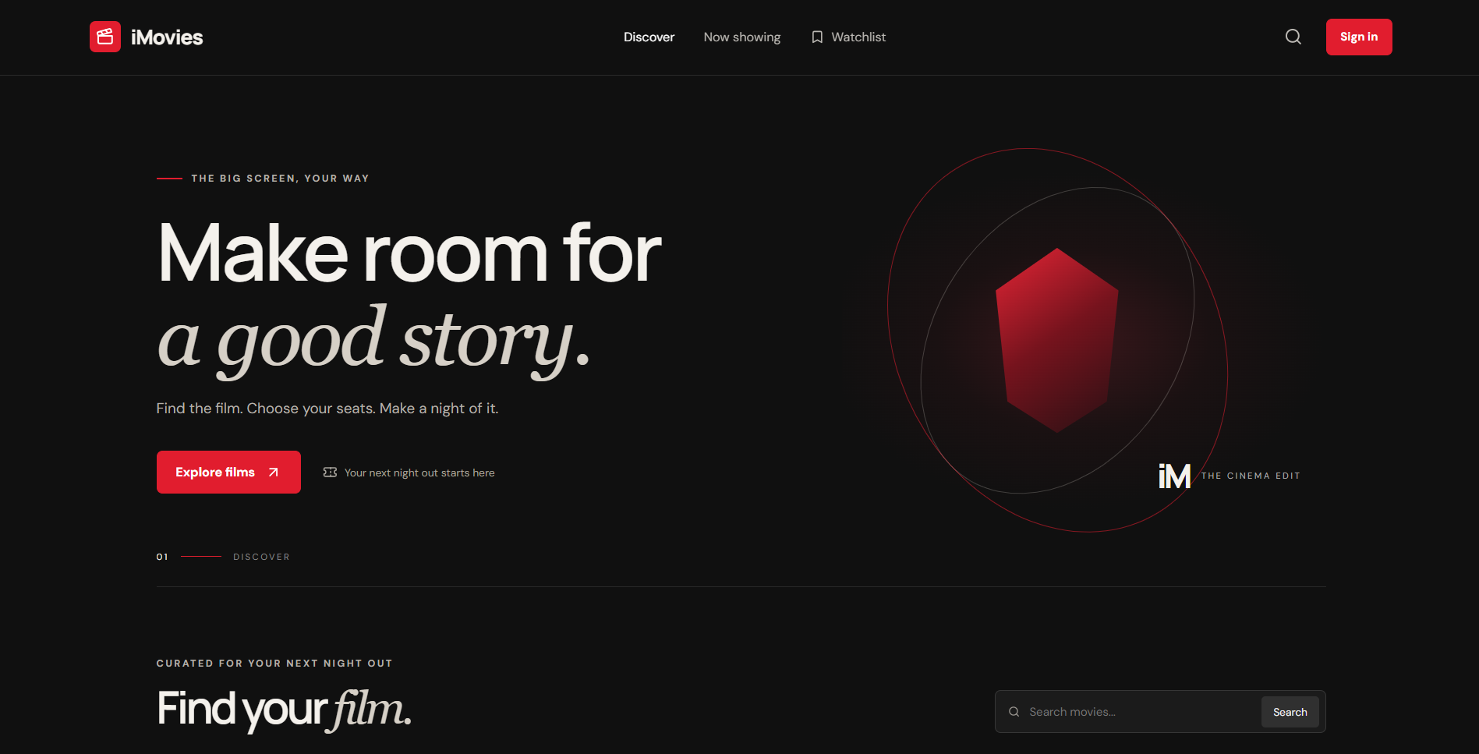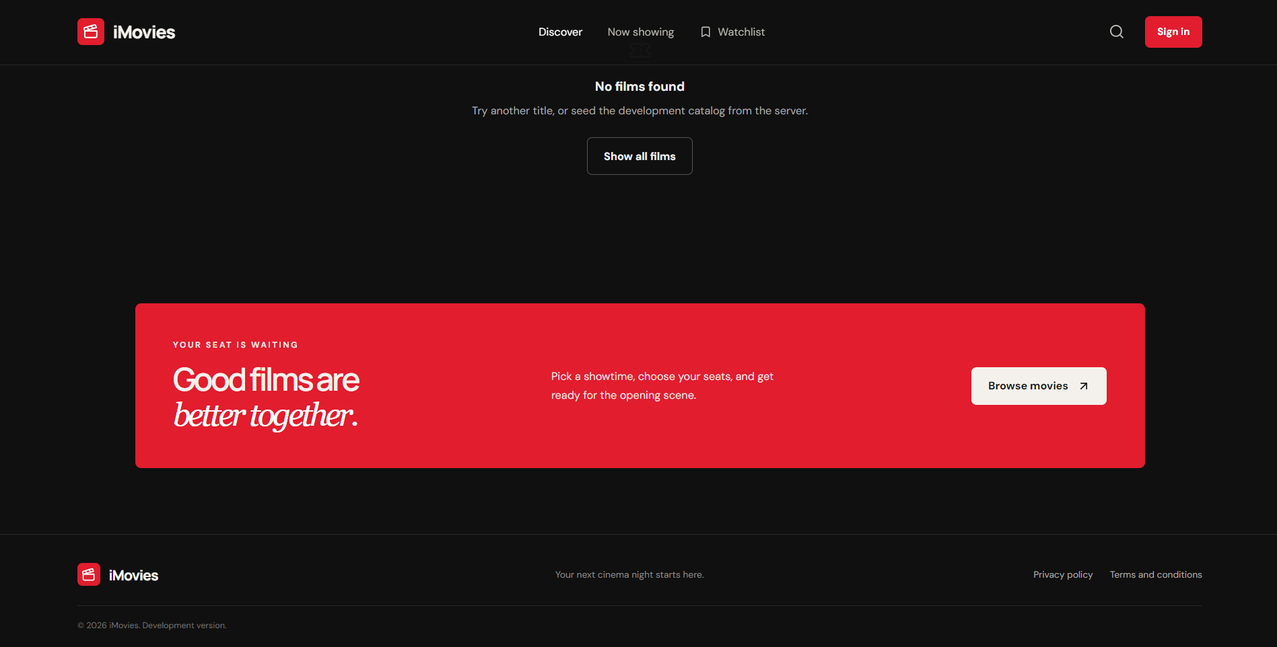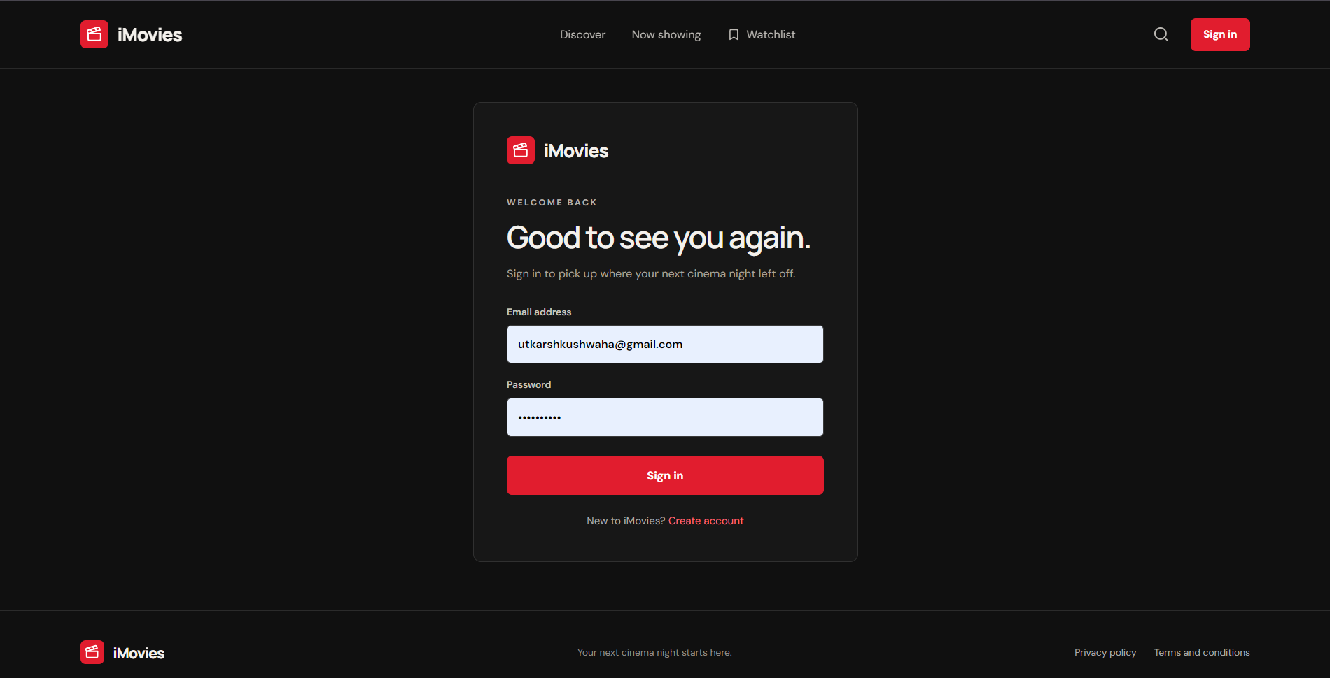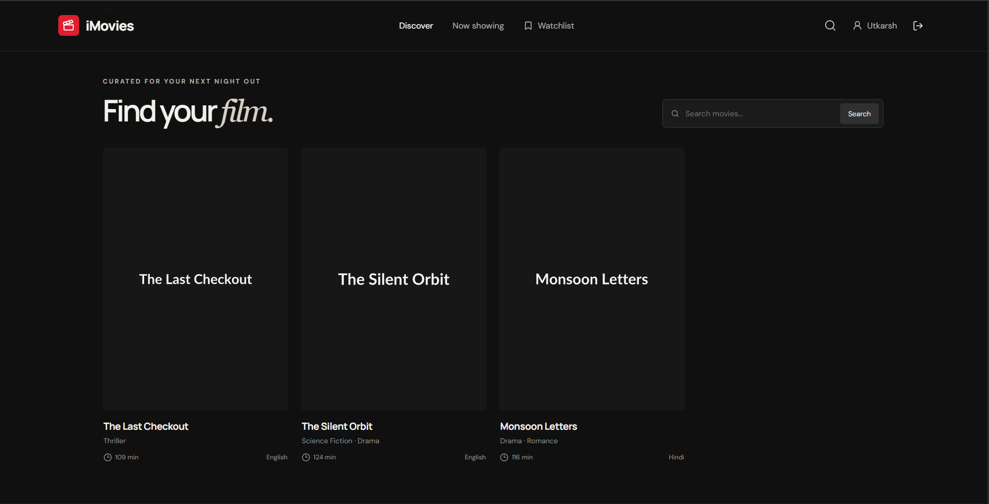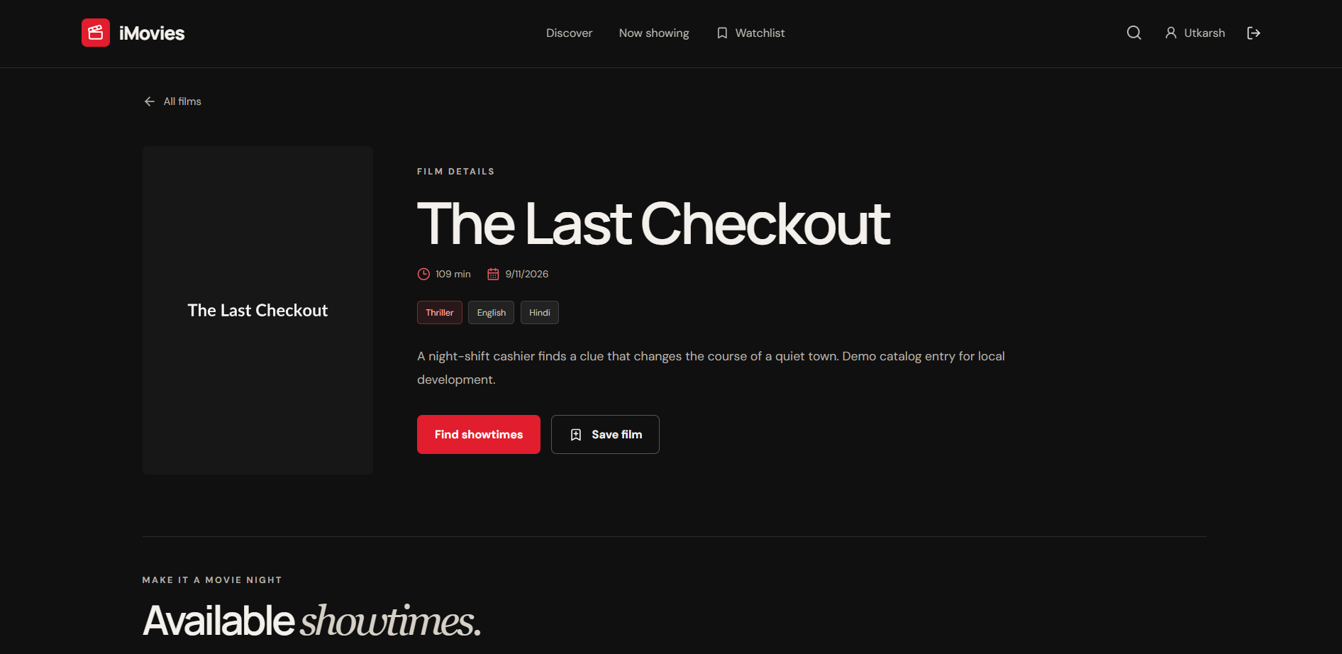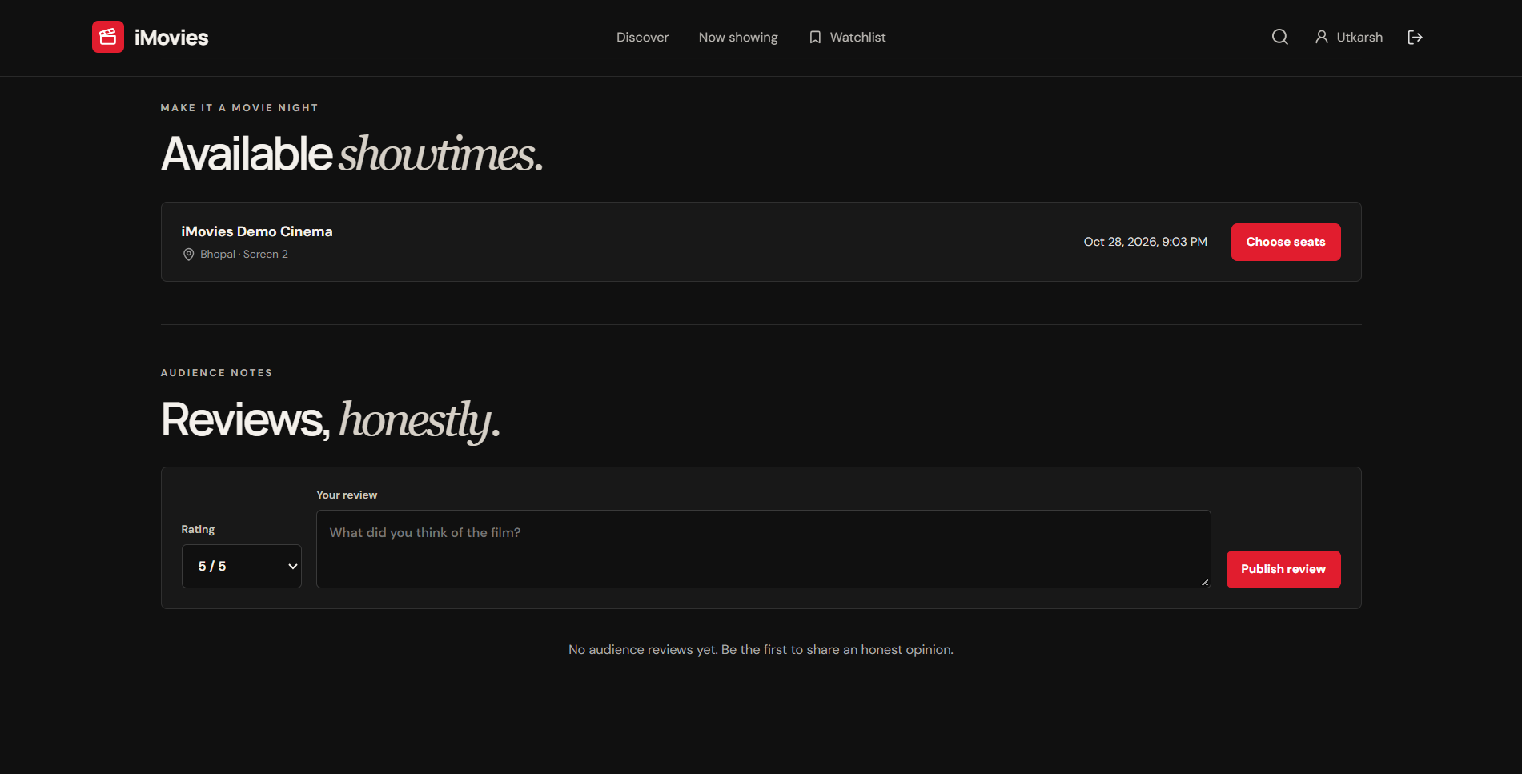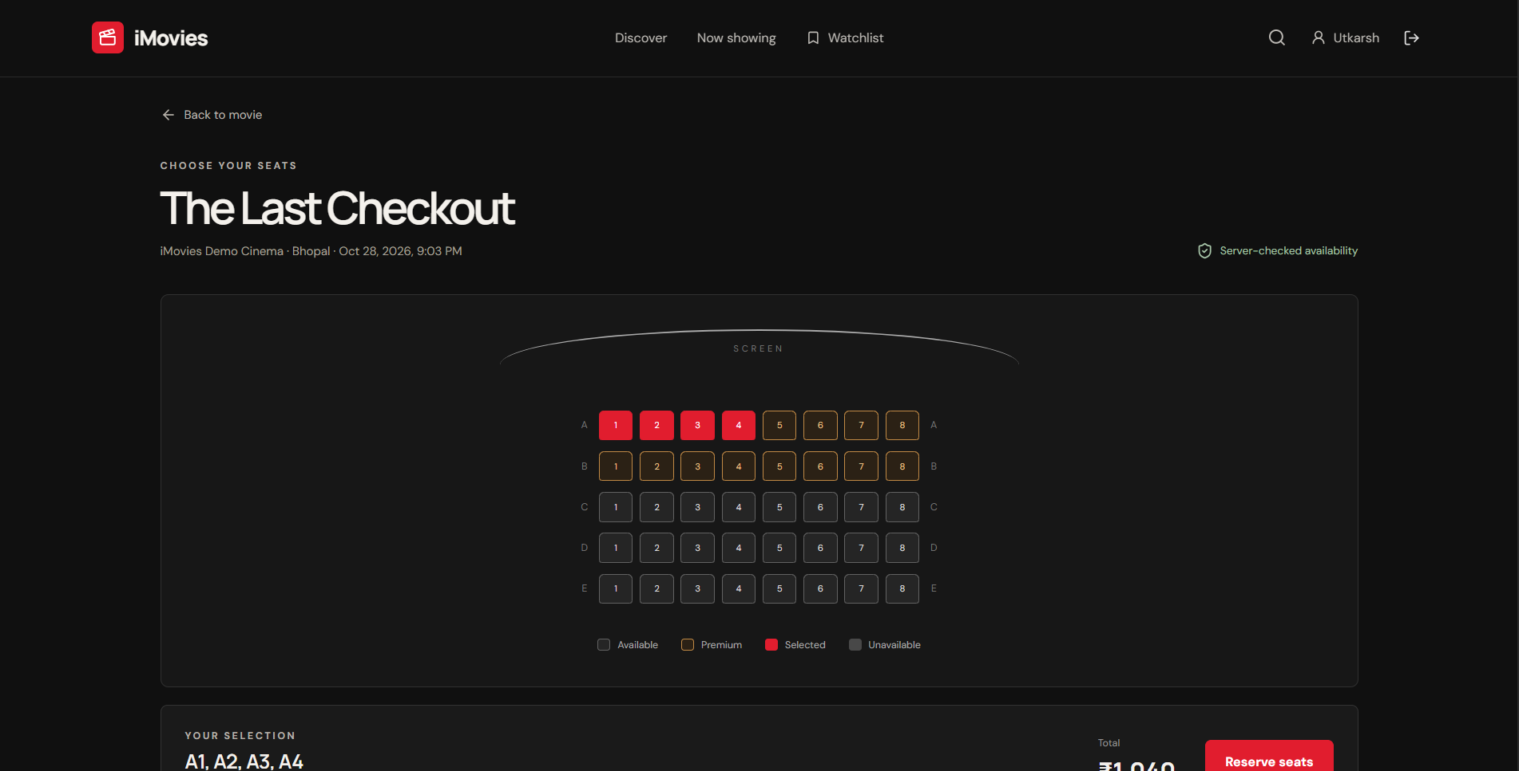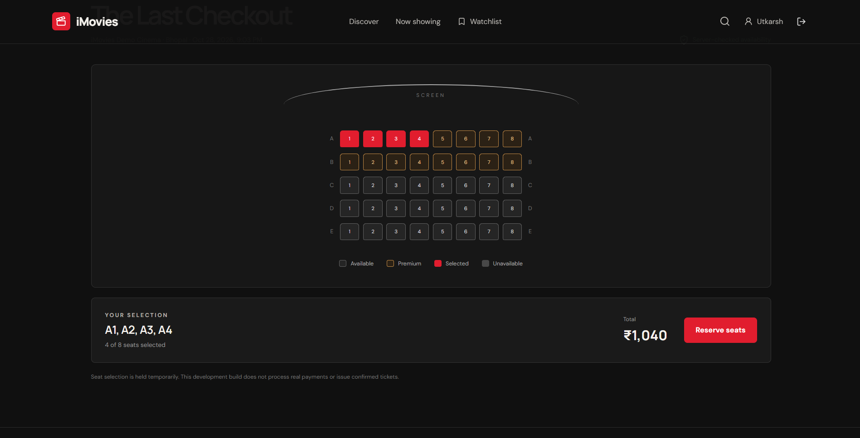

12. Known Issues
- Payments are simulated: no real gateway is connected and refunds are only marked as initiated.
- Emails are printed to the server console unless the SMTP_* variables are set.
- The seeded shows are scheduled one day ahead, so "No upcoming shows" appears later until an admin schedules new ones.
- Port 5000 may already be in use (for example macOS AirPlay); change PORT in server/.env and the proxy target in client/vite.config.js.
- The seeded admin password is public in the README and must be changed before any real deployment.
- No automated tests exist.

13. Future Enhancements
- Real payment gateway (for example Razorpay or Stripe) with actual refunds
- Automated unit and API tests, and CI
- SMS and email ticket delivery with a QR code
- Poster and image upload by admins instead of URLs
- Food and beverage add-ons, coupons and offers
- Movie recommendations based on favourites and past bookings
- Multi-language interface and a mobile app

